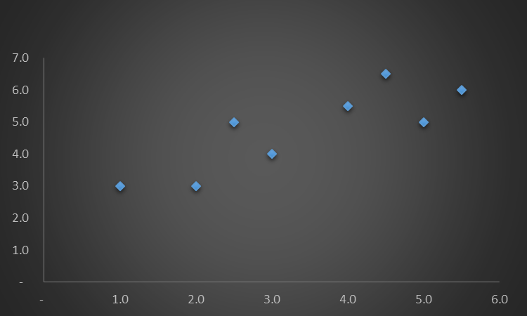We will do a dry run on the below dataset.

|  |  |
| --- | --- |
| x | y |
| - |  |
| 1.0 | 3.0 |
| 2.0 | 3.0 |
| 2.5 | 5.0 |
| 3.0 | 4.0 |
| 4.0 | 5.5 |
| 4.5 | 6.5 |
| 5.0 | 5.0 |
| 5.5 | 6.0 |

We plot the dataset it will look like as below

First, we generate a series of lines with a common intercept of 0 and varying slopes. For each line, we calculate the Y values (Y1, Y2, Y3, Y4, Y5, Y6, Y7) based on the specified x values. Next, we compute the error for each line by comparing the calculated Y values to the actual data. To visualize the relationship between error, slope, and intercept, we plot these parameters on a 3D axis. This process is repeated iteratively until we achieve the desired result. Here will repeat the process for 4 times for a better understanding of the process.

|  |  |  |  |  |  |  |  |  |  |  |  |  |
| --- | --- | --- | --- | --- | --- | --- | --- | --- | --- | --- | --- | --- |
| The calculation for possible best-fit line | | | | | | | | | | | | |
|
|  | **when intercept (C) =** | | | | **0** | **0** | **0** | **0** | **0** | **0** | **0** |  |
|  | **when slope or coefficient (m) =** | | | | 1.3 | 1.2 | 1.1 | 1 | 0.9 | 0.8 | 0.8 |  |
|  |  | | | | | | | | | | |  |
|  |  | **x** | **y** |  | **Y1** | **Y2** | **Y3** | **Y4** | **Y5** | **Y6** | **Y7** |  |
|  |  | **-** | - |  | y = mx + c |  |  |  |  |  |  |  |
|  |  | **1** | 3 |  | y = (1.3 x 1) + 0 = 1.3 | 1.2 | 1.1 | 1.0 | 0.9 | 0.8 | 0.8 |  |
|  |  | **2** | 3 |  | y = (1.3 x 2) + 0 = 2.6 | 2.4 | 2.2 | 2.0 | 1.8 | 1.6 | 1.5 |  |
|  |  | **2.5** | 5 |  | y = (1.3 x 2.5) + 0 = 3.25 | 3.0 | 2.8 | 2.6 | 2.3 | 2.1 | 1.9 |  |
|  |  | **3** | 4 |  | y = (1.3 x 3) + 0 = 3.9 | 3.6 | 3.4 | 3.1 | 2.8 | 2.5 | 2.3 |  |
|  |  | **4** | 5.5 |  | y = (1.3 x 4) + 0 = 5.2 | 4.8 | 4.5 | 4.1 | 3.7 | 3.3 | 3.0 |  |
|  |  | **4.5** | 6.5 |  | y = (1.3 x 4.5) + 0 = 5.85 | 5.4 | 5.0 | 4.6 | 4.1 | 3.7 | 3.4 |  |
|  |  | **5** | 5 |  | y = (1.3 x 5) + 0 = 6.5 | 6.0 | 5.6 | 5.1 | 4.6 | 4.1 | 3.8 |  |
|  |  | **5.5** | 6 |  | y = (1.3 x 5.5) + 0 = 7.15 | 6.6 | 6.2 | 5.6 | 5.1 | 4.5 | 4.2 |  |
|  |  |  |  |  |  |  |  |  |  |  |  |  |
|  |  |  |  |  |  |  |  |  |  |  |  |  |

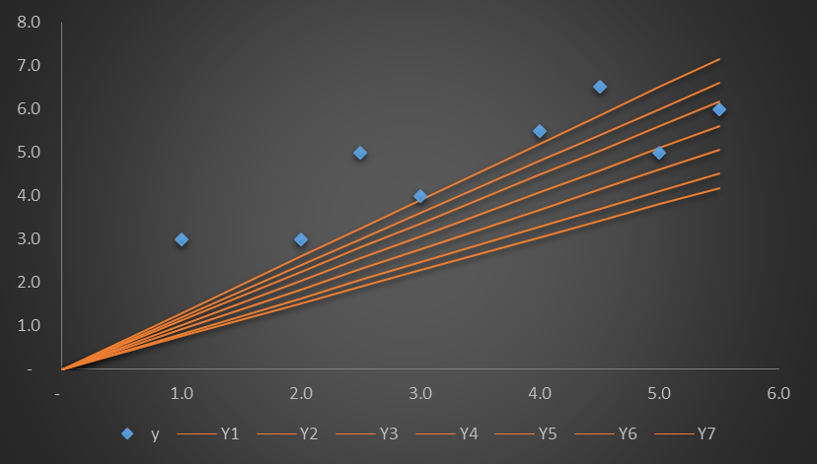

|  |  |  |  |  |  |  |  |  |  |  |  |  |  |  |  |  |  |  |  |
| --- | --- | --- | --- | --- | --- | --- | --- | --- | --- | --- | --- | --- | --- | --- | --- | --- | --- | --- | --- |
|  | Calculation for Error | | | | | | | |  |  |  |  |  |  |  |  |  |  |  |
|  |  | **Y1** | **Y2** | **Y3** | **Y4** | **Y5** | **Y6** | **Y7** |  |  |  |  |  |  |  |  |  |  |  |
|  | Error Formula (y-y)2 | |  |  |  |  |  |  |  |  |  |  |  |  |  |  |  |  |  |
|  |  | 1-1.3=0.09 | 0.0 | 0.0 | - | 0.0 | 0.0 | 0.1 |  |  |  |  |  |  |  |  |  |  |  |
|  |  | 2-2.6=0.36 | 0.2 | 0.1 | - | 0.0 | 0.1 | 0.2 |  |  |  |  |  |  |  |  |  |  |  |
|  |  | 2.5-3.2=0.56 | 0.3 | 0.1 | - | 0.0 | 0.2 | 0.4 |  |  |  |  |  |  |  |  |  |  |  |
|  |  | 3-3.9=0.81 | 0.4 | 0.1 | - | 0.1 | 0.3 | 0.5 |  |  |  |  |  |  |  |  |  |  |  |
|  |  | 4-5.2=1.44 | 0.6 | 0.2 | 0.0 | 0.1 | 0.5 | 0.9 |  |  |  |  |  |  |  |  |  |  |  |
|  |  | 4.5-5.8=1.82 | 0.8 | 0.3 | 0.0 | 0.1 | 0.7 | 1.2 |  |  |  | Y1 | Y2 | Y3 | Y4 | Y5 | Y6 | Y7 |  |
|  |  | 5-6.5=2.25 | 1.0 | 0.4 | 0.0 | 0.2 | 0.8 | 1.4 |  |  | Slope | **1.3** | **1.2** | **1.12** | **1.02** | **0.92** | **0.82** | **0.76** |  |
|  |  | 5.5-7.1=2.72 | 1.2 | 0.4 | 0.0 | 0.2 | 1.0 | 1.7 |  |  | Error | 2.51 | 1.12 | 0.4 | 0.01 | 0.18 | 0.91 | 1.61 |  |
|  | **Error** | **2.5** | **1.1** | **0.4** | **0.0** | **0.2** | **0.9** | **1.6** |  |  | Intercept | 0 | 0 | 0 | 0 | 0 | 0 | 0 |  |
|  |  |  |  |  |  |  |  |  |  |  |  |  |  |  |  |  |  |  |  |

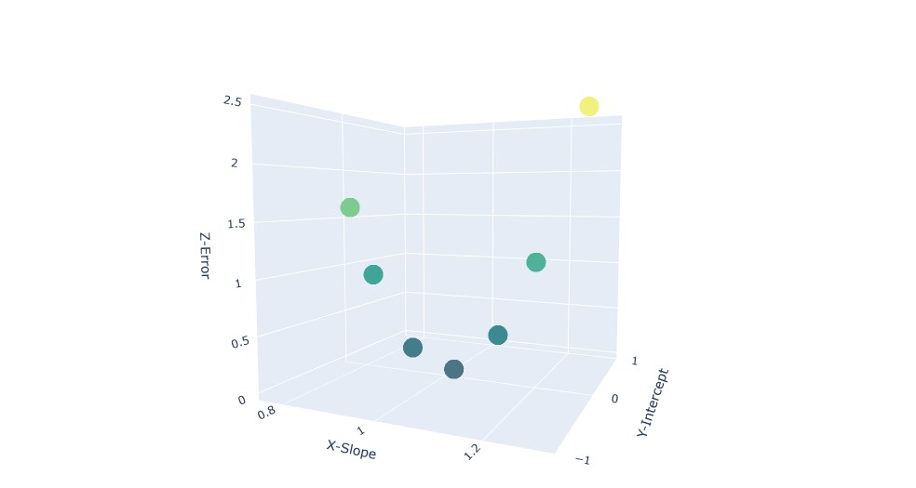

|  |  |  |  |  |  |  |  |
| --- | --- | --- | --- | --- | --- | --- | --- |
|  | Y1 | Y2 | Y3 | Y4 | Y5 | Y6 | Y7 |
| Slope | 1.40 | 1.25 | 1.10 | 0.95 | 0.80 | 0.65 | 0.45 |
| Error | 11.97 | 7.18 | 3.65 | 1.38 | 0.37 | 0.61 | 2.89 |
| Intercept | 1.00 | 1.0 | 1.0 | 1.00 | 1.00 | 1.00 | 1.00 |

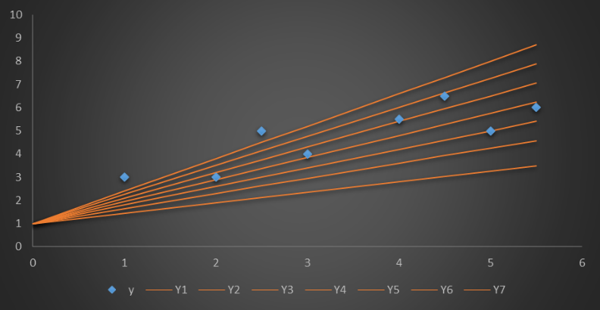

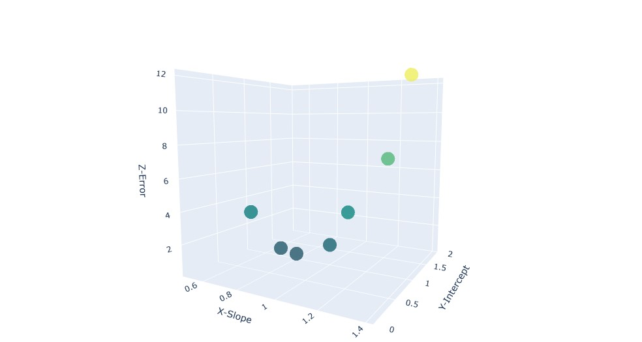

|  |  |  |  |  |  |  |  |
| --- | --- | --- | --- | --- | --- | --- | --- |
|  | **Y1** | **Y2** | **Y3** | **Y4** | **Y5** | **Y6** | **Y7** |
| Slope | 1.00 | 0.90 | 0.80 | 0.70 | 0.60 | 0.50 | 0.40 |
| Error | 4.50 | 2.72 | 1.49 | 0.83 | 0.72 | 1.17 | 2.18 |
| Intercept | 1.5 | 1.5 | 1.5 | 1.5 | 1.5 | 1.5 | 1.5 |

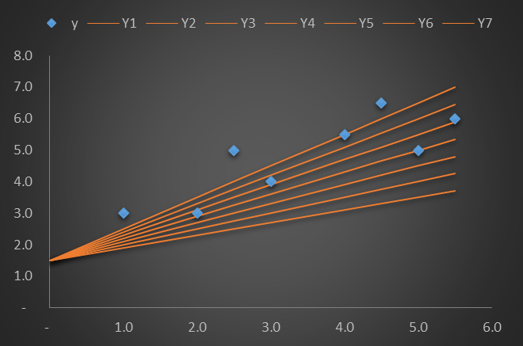

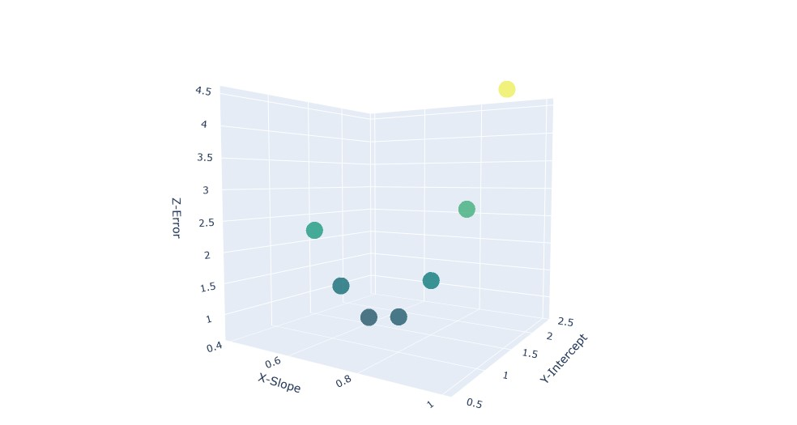

|  |  |  |  |  |  |  |  |
| --- | --- | --- | --- | --- | --- | --- | --- |
|  | **Y1** | **Y2** | **Y3** | **Y4** | **Y5** | **Y6** | **Y7** |
| slope | 1.00 | 0.82 | 0.66 | 0.53 | 0.43 | 0.33 | 0.23 |
| Error | 8.00 | 3.96 | 1.88 | 1.25 | 1.40 | 2.12 | 3.39 |
| Intercept | 2.00 | 2.00 | 2.00 | 2.00 | 2.00 | 2.00 | 2.00 |

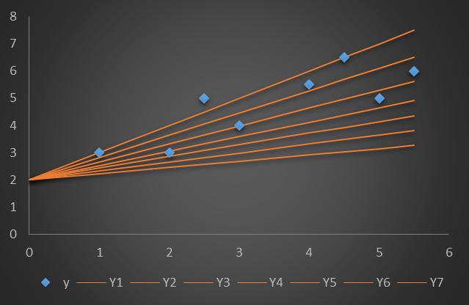

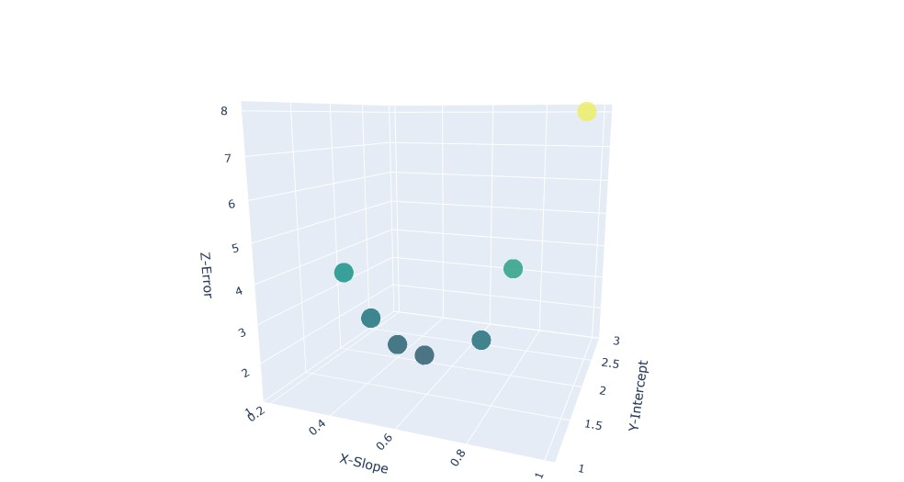

|  |  |  |  |  |  |  |  |
| --- | --- | --- | --- | --- | --- | --- | --- |
|  | **Y1** | **Y2** | **Y3** | **Y4** | **Y5** | **Y6** | **Y7** |
| Slope | 0.90 | 0.77 | 0.64 | 0.51 | 0.41 | 0.31 | 0.21 |
| Error | 9.34 | 6.07 | 3.75 | 2.36 | 1.94 | 2.08 | 2.78 |
| Intercept | 2.5 | 2.5 | 2.5 | 2.5 | 2.5 | 2.5 | 2.5 |

